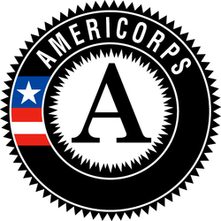
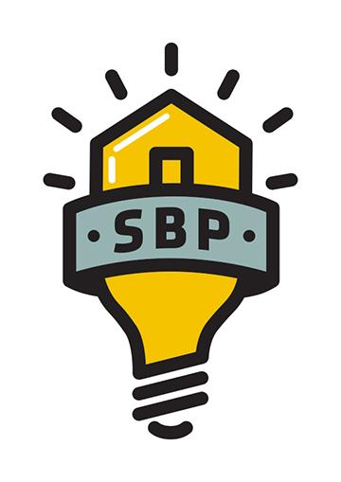
SBP AmeriCorps Volunteer Coordinator

Service Position Summary:
SBP is an award-winning, nonprofit rebuilding organization whose mission is to ensure that disaster-impacted citizens and communities recover in a prompt, efficient and predictable manner. Through Disaster Recovery Lab, SBP works to share lessons learned, prevent common barriers to recovery and help communities utilize SBP’s standardized, repeatable and proven-effective model. Since its founding in 2006, in response to Hurricane Katrina, SBP has rebuilt homes for over 2300 families with the help of over 130,000 volunteers in New Orleans and Baton Rouge, LA; Joplin, MO; Rockaway, NY; Monmouth and Ocean Counties, NJ; San Marcos, TX; Columbia, SC; Houston, TX; Bay County, FL; North Carolina; and Puerto Rico.
Volunteer Coordinators support SBP’s mission by creating an extraordinary volunteer experience that gets people excited about volunteering with SBP. Volunteer Coordinators handle all volunteer logistics, support volunteer fundraising efforts that directly support the AmeriCorps project, speak with energy to large groups of volunteers about SBP before and after their volunteer build, communicate with multiple SBP departments to ensure volunteers have a quality experience, and spread the word about SBP at local outreach events. As the first point of contact for many volunteers, Volunteer Coordinators must be comfortable expressing thanks, talking about the state of the recovery, and articulating the ongoing need for support. Volunteer Coordinators serve as the point of contact for multiple volunteer groups that register to volunteer anywhere from a day to a year in advance, answering all questions, relaying all updates and documenting logistics. Volunteer Coordinators serve diligently both before and after the volunteer group’s build experience encouraging volunteers to become further engaged in SBP, beyond just volunteering.
Essential Functions of Position:
- Respond to volunteer requests, questions, or general inquiries via email and phone in a timely fashion
- Coordinate all trip logistics for volunteers. This includes being the point of contact for multiple volunteer groups in any given week: both volunteers currently on site and those registering for weeks or months in advance.
- Accurately document all communications and logistics.
- Use of volunteer management software including Salesforce, Formstack, Google spreadsheets, and Classy.
- Update and track volunteer information on Google documents used by multiple departments
- Assess availability of volunteer work and schedule volunteer groups
- Give orientations to as many as 150 volunteers at a time
- Give debriefings at the end of each volunteer experience
- Encourage groups to stay engaged with SBP by returning to volunteer or spreading the work
- Clearly communicate the enduring needs of our clients
- Spend no more than 10% of the AmeriCorps service term engaging volunteers in fundraising efforts that support the fundraising goals of the AmeriCorps project.
- Maintain updated records and routinely track volunteer information, including volunteer numbers, contributions and feedback.
- Keep volunteers informed about upcoming SBP events
- Maintain an energetic and positive attitude with volunteers and colleagues
- Build partnerships with local businesses and community organizations to support fundraising efforts that support the goals of the AmeriCorps project.
- Participate in outreach and planning for volunteer special events that support the goals of the AmeriCorps project.
- Communicate with entire SBP team about the role, function and needs of volunteers
- Participate in September 11th Day of Remembrance and Martin Luther King Jr. Day of Service events, which may take place on a weekend or during holidays and include activities outside of the scope of typical day-to-day functions.
  - Per 45 CFR §2510.20, SBP has determined that the probability of access to vulnerable populations is so great that all members will receive the three-part NSCHC: NSOPR, FBI, and required state components (residence and state of service, as necessary).
  - Per 45 CFR §2540.100, member activities are not supplementing, duplicating, or displacing staff or volunteers.

Knowledge, Skills, and Abilities Required:
- Be at least 17 years of age or older.
- Have a high school diploma or its equivalent
- Be a citizen, national, or lawful permanent resident alien of the United States
- Satisfy the National Service Criminal History Check eligibility criteria pursuant to 45 CFR 2540.202.
- Strong interpersonal skills, including active listening.
- Ability to maintain a calm, professional demeanor in challenging situations, including volunteer crises.
- Ability to clearly communicate needs and expectations to people of various backgrounds.
- Demonstrated problem solving skills.
- Fluency in Spanish required for positions serving at the Puerto Rico Operating Site

Academic, Experience, and Core Competencies Needed:
- Excellent multi-tasking, organization, prioritizing and time management skills in an office setting
- Excellent verbal and written communication skills
- Strong attention to detail in the use of software such as Google spreadsheets, Salesforce & Formstack
- Experience/comfort with public speaking
- Comfort engaging volunteers to support SBP’s mission beyond just the volunteer experience
- Ability to juggle a wide variety of tasks and set own to-do deadlines
- Willingness /enthusiasm to receive constructive feedback from your manager and peers
- Problem solving abilities
- Ability to take initiative and be self-motivated
- Positive attitude / capacity to inspire and motivate others
- Strong interpersonal skills and ability to work with a diverse range of individuals
- Strong passion for the work of the SBP
- Ability to handle team conflict in a positive manner
- Ability to handle swings in workload to accommodate high and low volunteer numbers
- Comfort driving around city to construction sites and events

Commitment Required: Full Time members will serve 1700 hours. Members are required to serve 42 hours a week. A typical service week is Monday – Friday, however volunteer events often occur on Saturday and will require attendance. Member will have ample opportunity to complete 1700 hours of service.
Member Evaluation: Members will receive mid-year and end of year evaluations, as well as complete necessary weekly and/or monthly data reports and bi-weekly timesheets in OnCorps.
Training:
- Members will receive service and site-specific training to prepare them for their service. Members will also be required to attend orientation.
- Member training hours meet the requirements of 45 CFR §2520.50.

AmeriCorps Program Benefits:
This position is eligible for a living allowance, post-service education award, health benefits, loan forbearance for most federally-guaranteed student loans, and childcare assistance. The stipend for this position is $1,427.90 per month and may not exceed $14,279.00 for the entire term of service. The education award for this position upon completion of the ten-month term and 1700 hours of service is $6195. Please visit http://www.americorps.gov/for_individuals/benefits/benefits_ed_award.asp for more information on the education award. AmeriCorps members in this position have the opportunity to make a difference in communities, connect to a national AmeriCorps network and alumni group, and serve with a dynamic team of members.

